From: Secrétariat ITA-AITES [mailto:secretariat@ita-aites.org]
Sent: Monday, June 14, 2021 11:44 AM
To: undisclosed-recipients:
Subject: ITA AWARDS 2021: Call for Entries

Dear President, Dear Madam, Dear Sir,

We are pleased to send you this information concerning the ITA Awards 2020. We encourage you to distribute this mail to your members.
Thank you in advance and best regards,

Claudia Clivaz Assistante / Secrétariat
AITES c/o MIE 2 (MAISON INTERNATIONALE DE L'ENVIRONNEMENT)

Chemin de Balexert 9, CH-1219 Châtelaine
Information in this email is confidential and may be legally privileged. It is intended solely for the addressee and access to this email by anyone else is unauthorised. If you are not the intended recipient, any disclosure, copying, distribution or any action taken or omitted to be taken in reliance on it, is prohibited and may be unlawful.

If you have received this email in error please notify the ITA secretariat to secretariat@ita-aites.org. Any views or opinions presented are solely those of the author and do not necessarily represent those of ITA. Any opinion or advice contained in this email is subject to the terms of the ITA disclaimer.

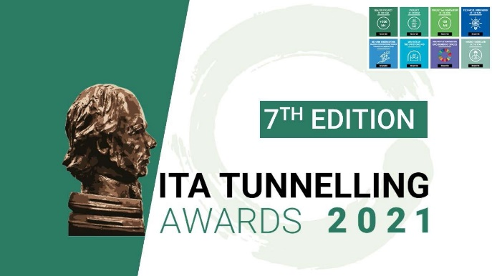

CALL FOR ENTRIES

The 7th edition of the international tunnelling and underground space awards welcomes new
applications until June 30, 2021

After the sucess of the last edition, the ITA Awards 2021 will be this year again in digital event. It will take place early December.

The entries can be submitted in
8 categories once again this year

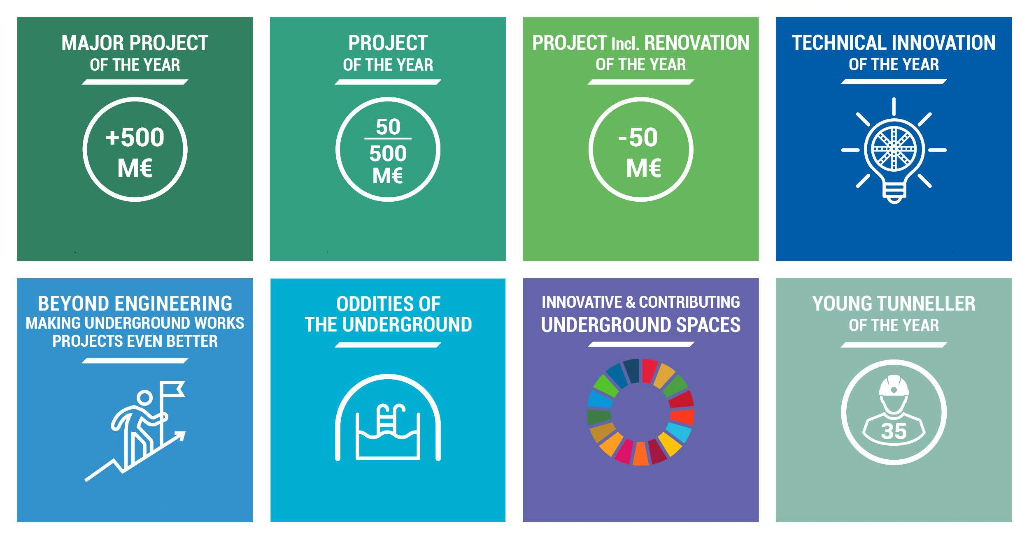

For this edition, we are making a small change in the categories notably to better specify what is expected in the category “ Beyond Engineering – Making Underground Works Projects Even Better“ replacing “Overcoming the challenge”.

- Major Project of the Year - over €500 million
- Project of the Year - between €50 million & €500 million
- Project of the Year incl. Renovation - up to €50 million
- Technical Innovation of the Year
- Beyond Engineering - making underground works projects even better
- Oddities of the Underground
- Innovative & contributing underground spaces
- Young Tunneller of the Year

Entries can be submitted through our dedicated website https://awards.ita-aites.org/account-creation

  ITA-AITES
  AITES c/o MIE 2
  Chemin de Balexert 9
  1219 Châtelaine
  Switzerland
  Email: communication@ita-aites.org
  ﻿> Disclaimer
  © ITA-AITES 2021
  To unsubscribe, click here

--
To unsubscribe from this group and stop receiving emails from it, send an email to wg20+unsubscribe@ita-aites.org.

-------- Конец пересылаемого сообщения --------

